Arduino Based Water Level Monitoring & Controlling System

## Dr. Rika Sharma Head of The Department

Amity University Chhattisgarh

Amity Institute of Information Technology

Tushar Sinha, Ravi Verma Bachelor of science (IT) Amity University Chhattisgarh [tushar.sinha1@s.amity.edu](mailto:tushar.sinha1@s.amity.edu) [ravi.verma@s.amity.edu](mailto:ravi.verma@s.amity.edu)

***Abstract***

This project provides us with a thorough understanding of water conservation through the use of a water level monitoring system. Industries and homes where water is used to a large extent can implement the given model to get the information about the water level in real-time. An ultrasonic sensor and a microcontroller are used to achieve the given results. The power of the internet may be used to further simplify things for users by allowing them to examine data from anywhere, offering them more options, power to monitor it from anywhere and giving them the power to achieve the control of water loss from everywhere. The need for this control arises due to the fact that water loss is happening at a critical rate and if not controlled the situation will worsen further.

**Keywords** – Arduino Uno, Water level monitor, Ultrasonic Sensor, Relay module

# Introduction

Villages in India will soon be transformed into smart villages as the Government of India launches the Smart Village initiative. The smart village initiative will promote digital inclusion which will enable the enhanced access to services through Information Technology (IT) enabled platforms. The Internet of Things (IoT) plays a significant part in India's Smart Village. Every physical object, or thing, in an IoT- enabled Smart Village will be connected to the Internet, allowing users to monitor and operate it remotely. This will help users to access to services provided by such objects as

and when required. IoT can be used in s mart village to develop Smart Agriculture, Smart Dairy, Smart Schools, Smart Healthcare and Smart Grid solutions IoT in agriculture can be utilised to manage crop production resources more effectively. Water is one of the important substances used in crop production. To prevent future water shortages, it must be preserved.. Monitoring and studying water use is one technique to save water, and as a result, water use should be controlled. In order to effectively manage water resources, it is important to regularly check the water level in water tanks, borewells, etc. A water source's water level can be monitored to conserve water and analyse water usage. The monitoring water level is an important task in agriculture.

# Problem Statement

Water waste is becoming increasingly problematic in India. Embedded systems are already playing an important role in the engineering design process for efficient analysis and successful operation. Because of the increasing complexity of electronic aspects throughout time, embedded systems have become an important component of our daily lives. As a result, using embedded technologies, we created a project that can measure the water level in a storage tank and show it on an LCD. Our project contributes to the solution of water scarcity issues. Furthermore, the usage of embedded systems decreases the possibility of inaccuracy induced by human involvement.

* 1. **Objective**

There are various goals that must be met in order to complete this project. These objectives will serve as a guide and will limit the system's implementation to specific situations:

1. Create a water level control system to regulate the water level in the tank.
2. To check the tank's water level. Depending on the water level, the motor turns on when the level falls below a predetermined level and turns off when the tank is filled.
3. To show the water level and other vital information on a 7-Segment Display.
4. To keep track of the tank's water level. When the tank's level falls below a certain threshold, the motor activates. Likewise, if the tank is full, the motor turns OFF.

# 2.Literature Review

1. In the study by P. Dietz, W. Yerazunis, and D. Leigh, the advantages of water level monitoring and control utilising Wi- Fi or wireless based monitoring using the Arduino are explained.
2. The paper of M. Javanmard, K.A. Abbas and FArvin deals with brief explanation of using Arduino to automate the homes. The limits of the Bluetooth method of automation were analysed to demonstrate that Android and Arduino make up for a better method of automation.
3. In the study by Hicks, F. Tyler, a water level monitoring prototype is created for online water level detection. An internet- connected core device, such as a microprocessor, receives commands to control sensors. Users and gadgets are

managed by a server. The front end for interacting with an Android application.

1. The cloud is a platform that links objects around us so that we may easily access any device from anywhere. Applications that utilise devices such as sensors require enormous storage capacity as well as massive computation power for real- time processing. Microcontroller Based Automated Water Level Sensing and Controlling: Design and Implementation Issue Proceedings of the World Congress on Engineering and Computer Science outlines an automation approach that employs the SHA-1 and Naive Bayes algorithms.
2. The design and implementation principles for a wireless real-time Water level monitoring system based on Arduino Uno microcontrollers as central controllers are provided in the work by

S.M. Khaled Reza, Shah Ahsanuzzaman Md. Tariq, and S.M. Mohin Reza. The suggested system operates in two modes.

i) Manually-automated mode, in which the user can monitor and operate home appliances from any location.

# Components

* **Arduino UNO -** The ATmega328P is the basis of the Arduino Uno microcontroller board. It has a USB connection, a power jack, six analogue input pins, 14 digital I/O pins, and a reset button. It comes with everything required to support the microcontroller; to get started, just use a USB cable to connect it to a computer, or an AC-to-Dc converter or battery to power it.

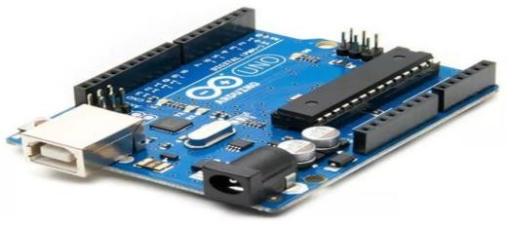

* **Ultrasonic Sensor -** As the name suggests, an ultrasonic sensor uses ultrasonic waves to calculate distance. It has 4 pins. VCC and ground for switching the sensor on. It has 4 pins. VCC and ground for switching the sensor on. Trigger pin is used to send ultrasonic signals that are received by echo pin. The arduino calculate the signals sending and receiving time and gives the result in distance by some calculation.

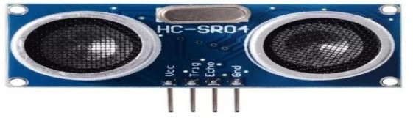

* **Water Pump -** It is a device that depends on the mechanical movement of fluid transport. The pumps are divided into three types according to the way the pump moves the liquid: direct lifting, displacement and gravity pumps. Pumps operate by energy consumption to

perform mechanical work by moving the liquid.

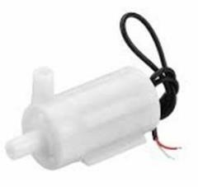

* **Relay Module -** Relays are used to electrically isolate two circuits and

connect them magnetically. When they are entirely apart, they can be used to switch from one circuit to another. An input segment and an output section make up the relays. A magnetic field is produced when a very little voltage from an electrical circuit is supplied to the coil of the input section. The operating voltage is the name given to this applied voltage.

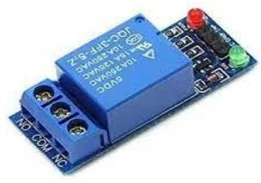

# Connections

### */HC-SR04 Ping distance sensor:

VCC to arduino 5v GND to arduino GND Echo to Arduino pin 9 Trig to Arduino pin 8*/

### */ Relay:

Relay IN 1 pin to Pin 13 of Arduino Vcc to 5V

Gnd to Gnd

# Working

The suggested method uses an ultrasonic sensor to determine the water level in percentage values. As explained before ultrasonic sensor has two apparatus namelytrig and echo. Trig is used to emit a sound wave to an objectas it is known that when a sound wave strikes an object

itbounces back with equal or more intensity which is called asecho. Echo part of ultrasonic sensor detects the reflected sound ray and returns the value according to that. It usually measures the time duration between trig and echo of sound ray.

The physical definition of velocity is the rate at which distance changes over time. If we neglect differentiation, velocity is given as ratio of distance to time. In this proposed system, the sound ray travel 2 times (Trig & Echo).

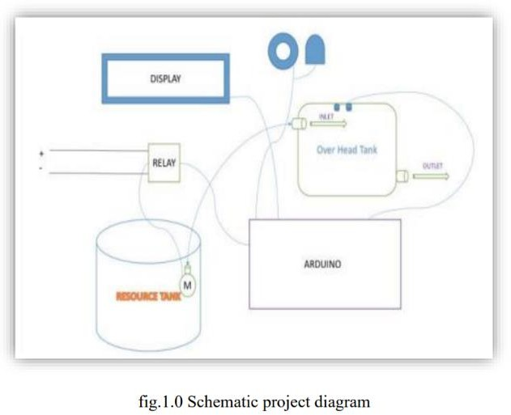

# Ultrasonic Sensor detection:

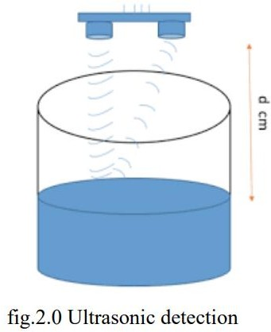

Ultrasonic sensor detects the object and measures the distance by following echo principle in this proposed system, water is also considered as object when a sound ray strikes water it results in generation of echo which is detected by the echo part of ultrasonic sensor. The working of ultrasonic sensor is given in fig (2). By measuring the time duration distance is determined.

# Relay module working:

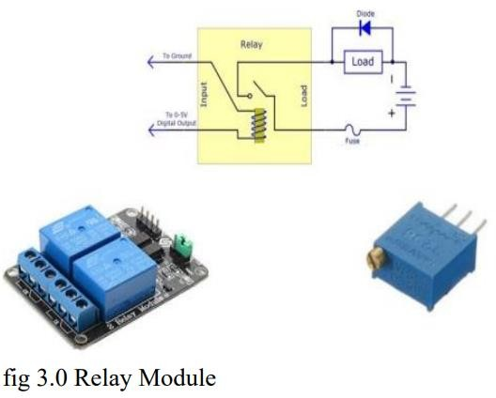

5V 1 channel Relay is used as external switch for Arduino to power external supply to the DC 12 V pump. Relay is usually in open condition it has continuous supply from Arduino board when a program is given to switch off the supply to relay then external switch is closed which powers external supply to the DC pump which is placed in resource tank. The working of relay is given in fig (3).

# Conditions Required:

Condition 1: Pump must on when tank level is >=10.

Condition 2: Relay module should turn on the pump automatic.

Condition 3: Serial monitor will print the distance betwwen sensor and water in ascending order.

Condition 4: Pump must off when tank level is <=2.

Condition 5: Relay module should turn off the pump automatic.

* 1. **Arduino IDE program:** #define echopin 9 // echo pin #define trigpin 8 // Trigger pin int maximumRange = 50;

long duration, distance; void setup() { Serial.begin (9600);

pinMode (trigpin, OUTPUT); pinMode (echopin, INPUT ); pinMode (4, OUTPUT);

pinMode (13, OUTPUT);

}

void loop () {

{

digitalWrite(trigpin,LOW); delayMicroseconds(2);

digitalWrite(trigpin,HIGH); delayMicroseconds(10);

duration=pulseIn(echopin,HIGH); distance=duration/58.2; delay(50);

Serial.print("water level :");

Serial.print(distance); delay(0);

}

if (distance <= 2 ){

digitalWrite (13,HIGH);// connect to relay(motor) digitalWrite (7,HIGH);

Serial.print("Tank is Full"); delay(0);

}

else if (distance >=10)

{

digitalWrite (7,LOW); // connect to relay(motor) digitalWrite (13,LOW);

Serial.print("Motor Started"); delay(0);

}

}

# Circuit diagram

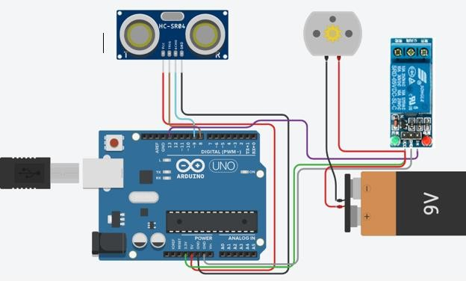

1. **Flow Chart**

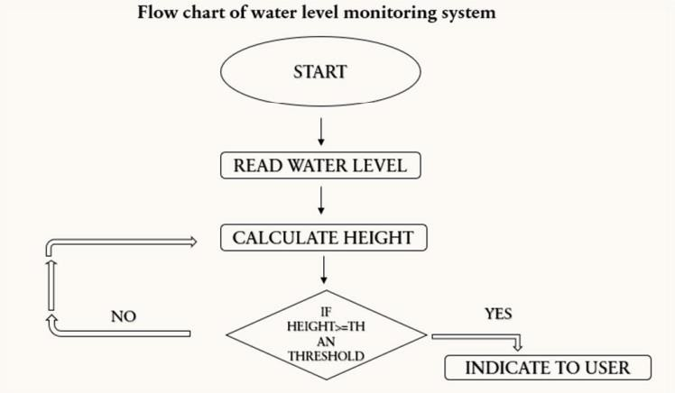

1. **Results and Snapshot**

The experimental model was made according to the circuit diagram and the results were as expected.

1. Water level is inversely proportional to the distance measured by ultrasonic sensor
2. Time duration is directly proportional to the distance.
3. Lesser time duration results in higher water level
4. High time duration results in lowest water level
5. Water level management is monitored for mentioned conditions.

# Snapshots of data from serial monitor

1. **Motor started when level is <=2**

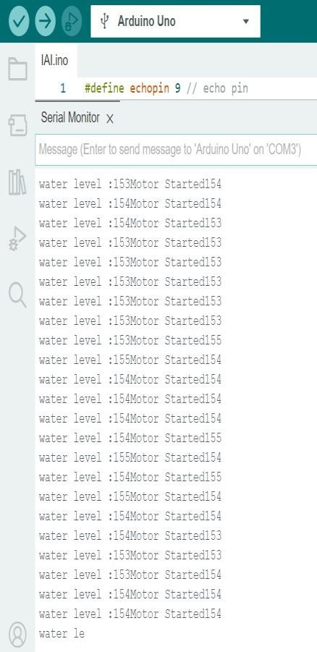

1. **Tank is full when level is >=10**

# Data of distance between sensor and water level

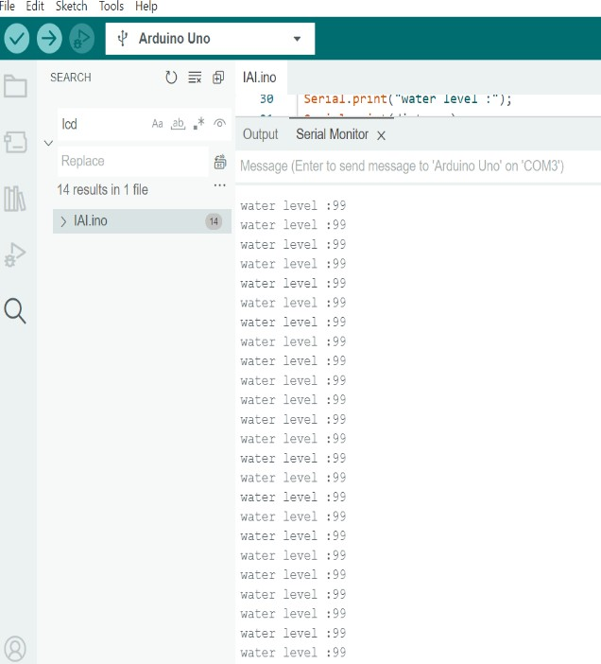

* 1. 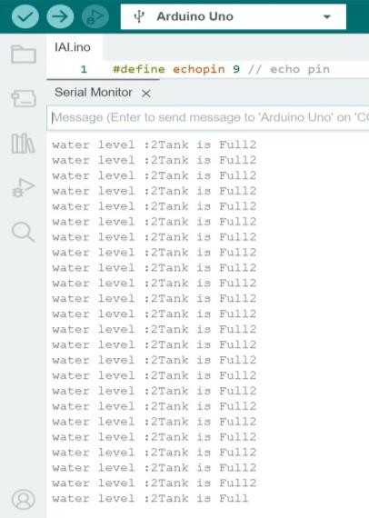**Results based on data**

|  |  |  |
| --- | --- | --- |
| Sr.no | Distance detected ultrasonic sensor | Water level |
| 1. | 10cm | Motor started |
| 2. | 2cm | Tank is  full |

1. **Conclusion**

The Internet has changed the dimensions of life involving virtual interaction.IOT has the ability to open up new possibilities by enabling communications amongst smarter items.. The project proposes a simple water level monitoring system with different levels indicated. Additionally, it indicates whether the water level is below or above what is necessary. System design and architecture is as discussed, thus being a cost effective and simple strategy to monitor the water level system. In order to reduce water waste, future work may involve analysing the water level in a specific location. We might also include the GSM-based system, which, when the water level drops below the required level, sends a message to the particular permitted person.

# Future Scope

This project has extensive scope in the industrial field and the housing sector; by using a level control loop it can be ensured that the water level does not cross a certain limit and also by using a pump it is ensured that a minimum height is always achieved. These days in our busy life we need messages as reminder in our phones or laptops that are connected by internet and this system can give reminders regarding the water level to the user every-time in his/her hand. It will also aid in the development of a smart city centred on the concept of water conservation.

# REFERENCES

1. Very Low-Cost Sensing and Communication Using Bidirectional LEDs, P. Dietz, W. Yerazunis, and D. Leigh, UbiComp 2011: Proceedings, vol. 2864, pp. 175'-191, 2003.
2. Pump Application Engineering, McGraw-Hill Book Company, New York; Hicks, F.; Tyler, G.; & Edwards, T.W.
3. "Microcontroller Based Automated Water Level Sensing and Controlling: Design and Implementation Issue," Proceedings of the World Congress on Engineering and Computer Science, vol. I, 2014. S.M. Khaled Reza, Shah Ahsanuzzaman Md. Tariq, and S.M. Mohin Reza.
4. M. Javanmard, K.A. Abbas, and F. Arvin, “A Microcontroller- Based Monitoring System for Batch Tea Dryer,” CCSE Journal of Agricultural Science, vol. 1, no. 2,201.
5. "Project Review on Water Level Sensing Using PLC," Osama Mahfooz, Mujtaba Memon, and Asim Iftikhar, Journal of Engineering & Technology Science, vol. 2, no. 2, pp. 160–170, 2012.
6. Jagadesh Boopathi, “555 Timer Based Water Level Controller,” Electronics Tutorials by Jagansindia, Inc., 23 June 2013.
7. See<http://ece.jagansindia.in/2013/06/555>

- timer- basedwater-level-controller.

1. "Prototype of water level detection system with wireless," S. Jatmiko, A. B. Mutiara, and Indriati, Journal of Theoretical and Applied Information Technology, Vol. 37, pp. 52–59, 2012.